

|  |  |
| --- | --- |
| **Name: Sayyed Sohail Rashid** | **Course Name: SMA-LAB** |
| **Class: BE-CO** | **Batch: 01** |
| **Roll no: 18CO48** | **Experiment No: 04** |

**Aim**: Exploratory Data Analysis and visualization of Social Media Data for business..

**Code:**

!pip install networkx

import networkx

G = networkx.Graph()

G.add_node(1)

G.add_node(2)

G.add_node(3)

G.add_node(4)

G.add_node(5)

G.nodes()

G.add_edge(1,2)

G.add_edge(1,2)

G.add_edge(1,3)

G.add_edge(4,3)

G.add_edge(4,3)

G.add_edge(5,4)

G.add_edge(2,3)

G.edges()

import networkx as nx

G = nx.Graph()

G.nodes()

G.edges()

import matplotlib.pyplot as plt

nx.draw(G)

plt.show()

nx.draw(G,with_labels=1)

plt.show()

G = nx.gnp_random_graph(10,0.5)

nx.draw(G)

**Output:**

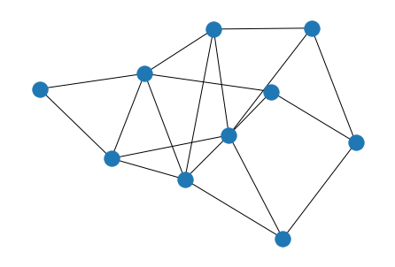

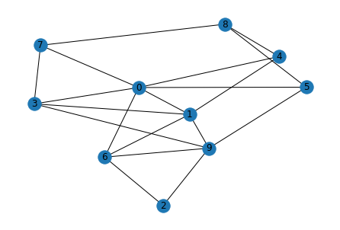

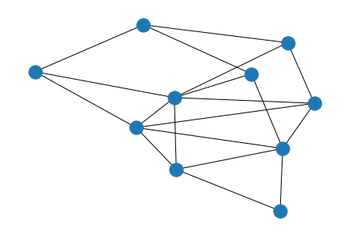

**Conclusion:**  We have successfully plotted the graphs for the analysis of Social Media Data.